Touchstone 3: Visual Design and Responsive Layout
STUDENT EXEMPLAR
Name | Suraj Mangrati
Course | Introduction to Web Development
Date | 10/16/2026
Selected Client | North Star Bakery

Section 1: Preview Link and GitHub Link
Paste the GitHub Repository Link: devN4t3d/TouchStone3IntroToWebDev
Working Project/Preview Link: North Star Bakery | Home

Section 2: Design Explanation

Respond to each prompt below. Focus on explaining your design decisions.

Your responses should reference specific elements from your website. General descriptions without examples may receive reduced credit.

Note: Your design should use 2 to 4 colors and no more than 2 font families, applied consistently across all pages.

Client Alignment

Explain how your design choices support your selected client’s goals and audience. Include at least one specific example from your website.

The client is keen on pre orders and inquiries. These have been accommodated by having the pre order form, as well as the contact form. By also listing the staff, the site caters to the client’s desire of being warm, and seeming community centered.

Color Palette
The main colors are cream (#FFF8F0), brown (#6B3E26), peach (#D88C5A), and charcoal (#2F2A26). List the 2 to 4 main colors you used (you may include hex codes). Explain how these colors support your client’s tone and ensure readability. Include one example of where you applied these colors.
(3–5 sentences)
The most visible colors in the site are #5b382a for the banner background, and #fff8ed for the body background. This is because the client runs a bakery, and it was important to keep the color as close as possible to that of wheat. This also makes sure that there is seamless integration with the images used in the site, which are mostly of wheat products.

Typography

Identify the font or font pair you used. Explain how your choices support readability and create visual hierarchy. Include one example of how you used font size, weight, or style.

(3–5 sentences)
Arial is the chosen font, based on it’s readability. H1 font was used for the site title in the main navigation bar, and h2 used for the page titles in the different pages. <p> tags were used for the body text in the different pages.

Responsive Design

Describe how your layout adapts across screen sizes. Include at least one specific example of a layout, spacing, or content change.

(3–5 sentences)

The client is keen on having the website display consistently across different screens. Therefore, media queries were used to ensure that the screen adjusts depending on the device used to access the site. This means that the experience was similar to all visitors, and they did not have to zoom in or zoom out when using the site.

Design Challenge

Describe one design challenge you encountered. Explain how you addressed it and what change you made.

(3–5 sentences)

Section 3: Submission Checklist
☐ Updated HTML files
☐ External CSS file
☐ Working preview link
☐ Consistent color palette (2–4 colors)
☐ Consistent typography (1–2 fonts)
☐ Styles applied across all pages
☐ Flexbox used in layout
☐ At least one media query
☐ Readable text with sufficient contrast
☐ Completed design explanation

Section 4: Screenshot
Include one screenshot of your website that demonstrates a design decision you described above.
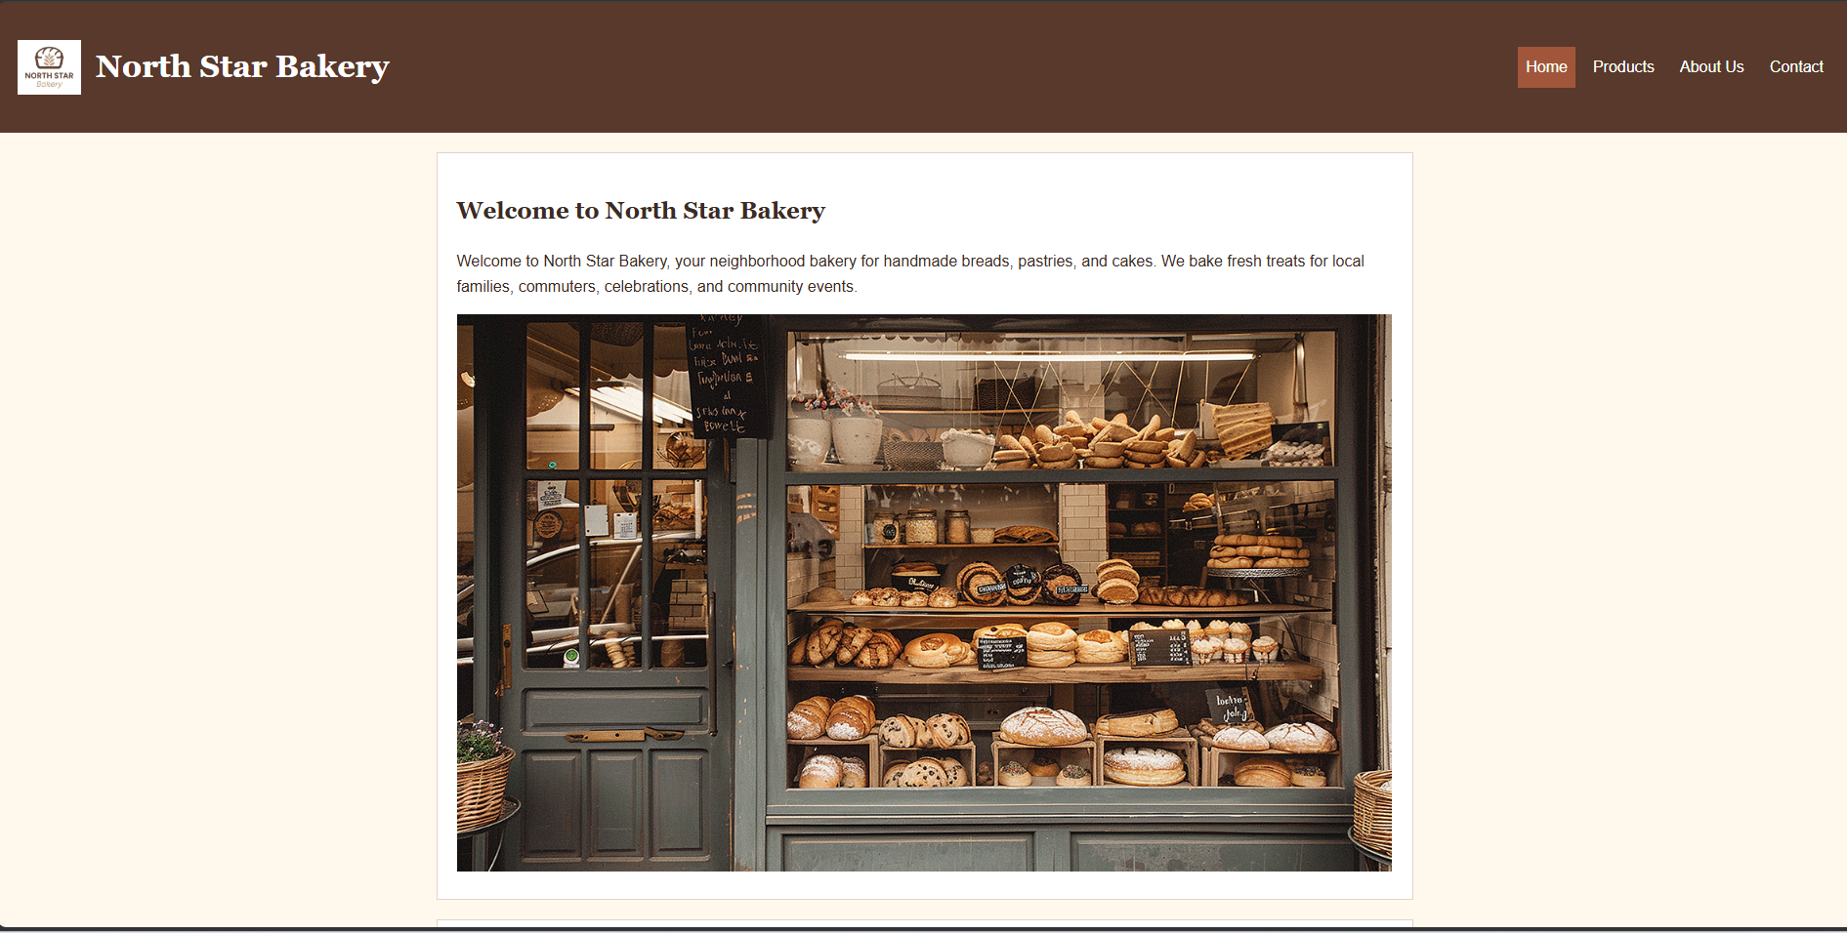

Section 5: Final Review
☐ All pages display correctly
☐ Navigation works across all pages
☐ Layout adjusts across screen sizes
☐ Design is consistent and readable

